COSTUME CHALLENGE
Create a costume and dress up like your favourite character from a book, tv show or film

Posties are dressing up to amuse people. Australians are being encouraged to dress up to take the rubbish out. Your next challenge is to create an inspiring dress up look inspired by your favourite book, tv or film. All you need is a pile of clothes; yours and other people’s in your bubble. If you have a sewing machine you might like to sew something otherwise it’s all about the styling. What you put with what. You could incorporate some recycled materials, things from the garden, garage, newspaper the possibilities are endless…
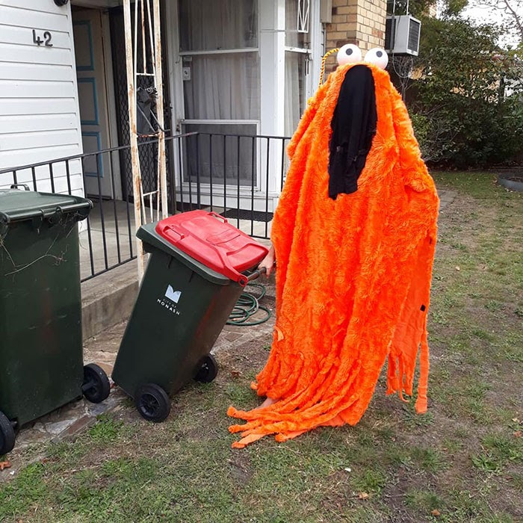
Decide on a character
Find a picture to inspire you
Gather your clothes, materials and equipment
Have some try-ons
Maybe do a sketch
Get making
Dress up
Strike a pose
Take a photo and send to terijohnson@kirkwood.school.nz
