ELECTRONICS CHALLENGE
Complete at least 5 circuit challenges. Take screen shots of your completed circuits
- Go to this website: https://epro8challenge.co.nz/electronics-simulator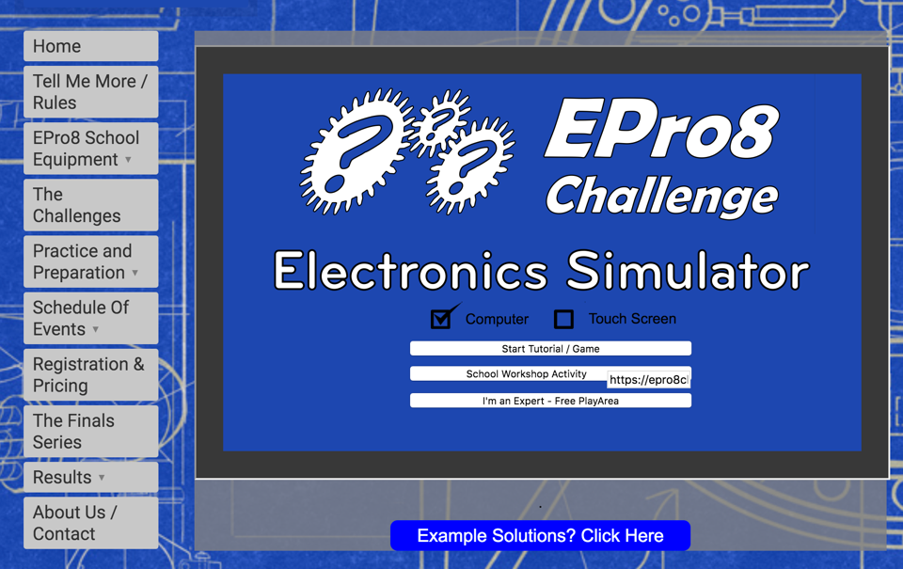
Click Start Tutorial/Game
- There are 21 different challenges (it is best to go in order from 1 to 21 as tips are given along the way)
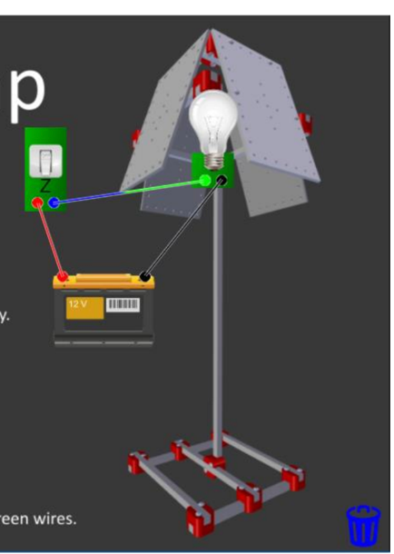
- You need to click and drag electronics components onto the premade image on your screen then you have to click on the coloured circles to add wires 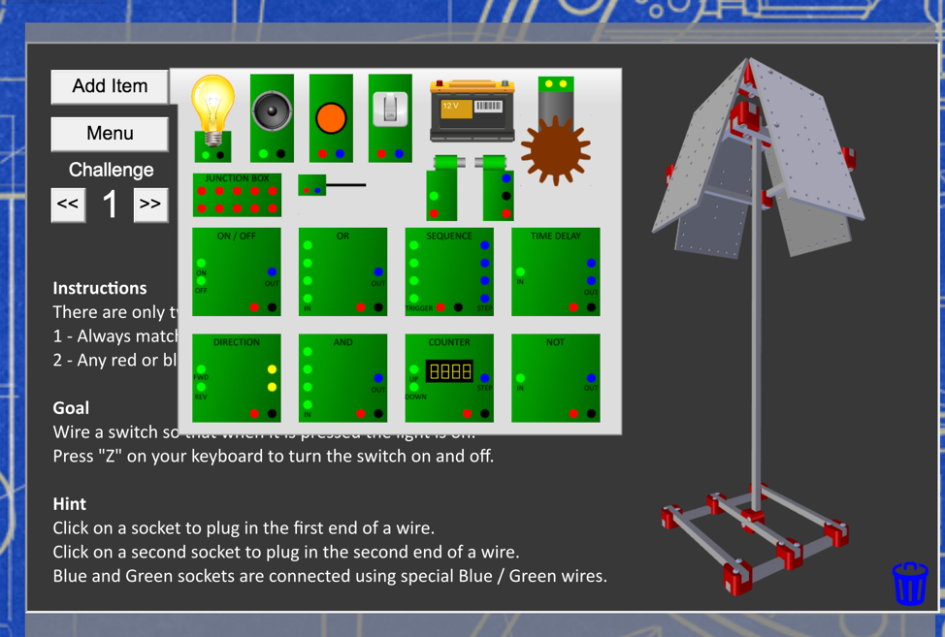

- Have a go at least 5 challenges
- Screenshot your work
- Send your screen shots to the tech team sarahwaters@kirkwood.school so we can see how you did

