SHOE BOX ROOM CHALLENGE
Create your ultimate bedroom, kitchen or playroom in a shoebox/box using materials that you find around your home.
Then create a digital model of your room.
- Go to this website https://floorplanner.com/
- Create an account using your email address (it’s free)

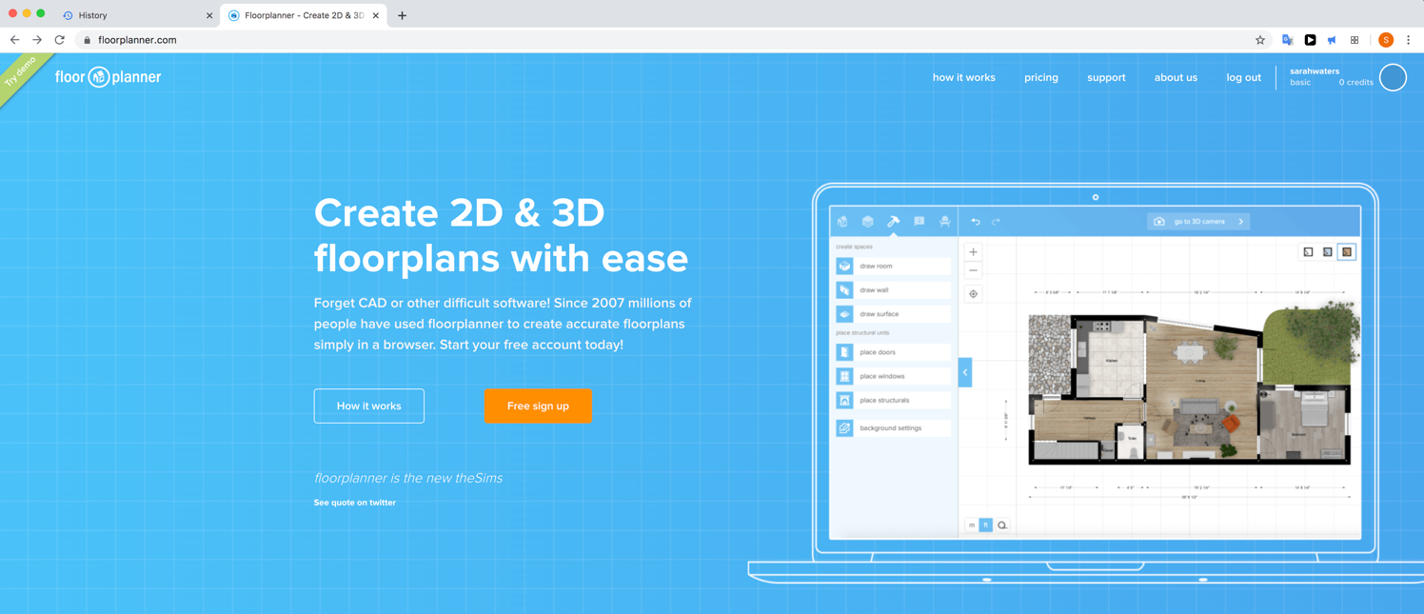

- Click “Try demo”
- Use the tabs to drag items in, change colours Switch views
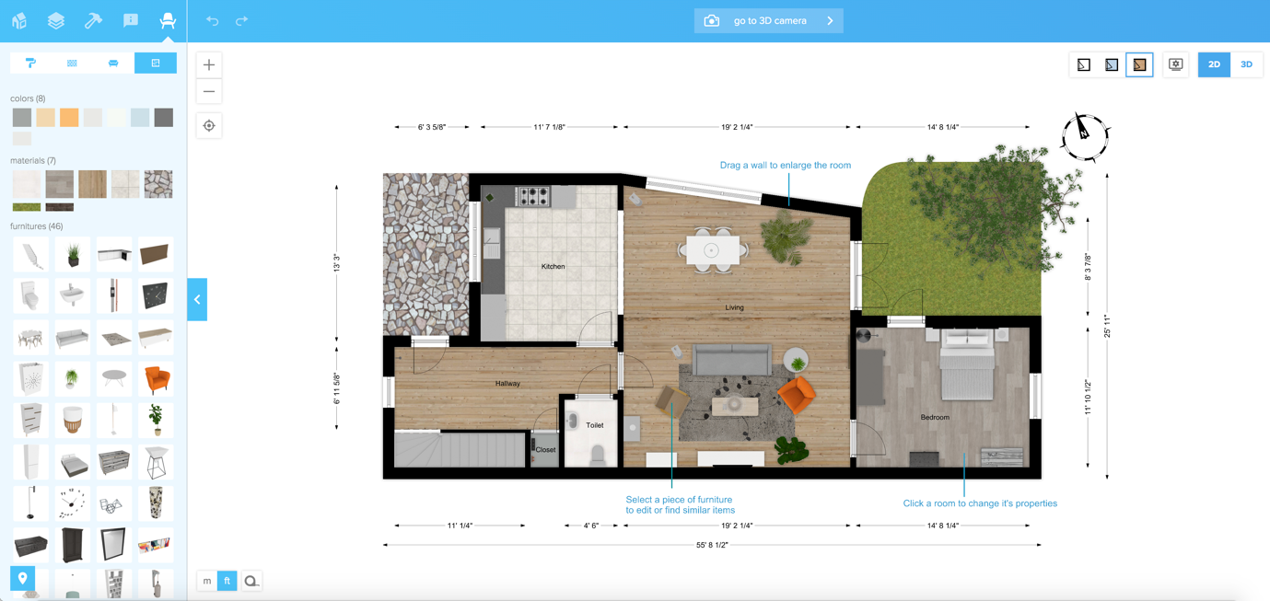
- Take a photo/screenshot and email your project to sarahwaters@kirkwood.school.nz

